Parents Reconciling Network Board Seeking New Board Members
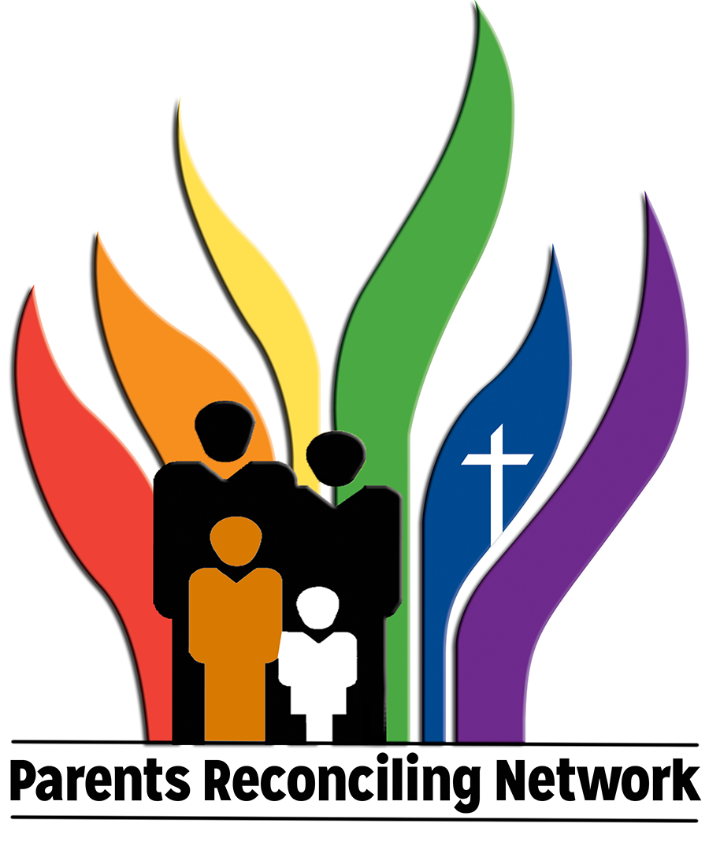
The Parents Reconciling Network (PRN) is seeking new board members. This is a significant time in the life of the United Methodist Church and for the movement toward full inclusion of LGBTQ+ persons in the church.

This is also an important time for parents and family members who have LGBTQ+ children/siblings in the UMC. More than ever, we need to offer support and encouragement to families with lesbian, gay, bisexual, transgender, queer, intersex, asexual (LGBTQ+) children/siblings.

While we do not know what will happen to the United Methodist Church at the General Conference in May, PRN will stand ready to continue to advocate for and to support families and their LGBTQ+ children/siblings.

Here are expectations for a member of the PRN Board:

- Parent of an LGBTQ+ child (the child can be of any age from school age to adult)
- Participant in/affiliated with a local United Methodist congregation
- Available to participate in every other month Zoom Conference Calls. Currently the calls take place in January, March, June, September, November – usually on the fourth Monday of the month. The call takes place during the day: 1:00 pm (Eastern), Noon (Central), 11:00 am (Mountain), and 10:00 am (Pacific)
- The board also gathers face to face at the Reconciling Ministries Convocations that are held between General Conferences and at the site of the General Conference. The face to face meetings are encouraged, but they are not mandatory.

Click HERE to download a copy of the PRN Board Member application. Please return the completed application to Rev. James Waugh – email address: jwaugh4@mac.com or mail address: 3292 Belstone Drive, Grove City, OH 43123.

We are currently accepting applications for new members through the end of October.

More information about the Parents Reconciling Network

When Did the Parents Reconciling Network begin?
Parents Reconciling Network (PRN) is an organization of United Methodist parents of Gay, Lesbian, Bisexual, and Transgender children. It began as an informal group in 1999 when Bruce and Virginia (Ginny) Hilton, both United Methodist pastors and parents of a gay child, brought parents together. Their purpose was to present a visible witness of parents in support of ending the denomination’s anti-homosexual stance and providing their homosexual children the same rights as heterosexual United Methodists at The United Methodist Church’s 2000 General Conference.

What does it mean for PRN to be an “Extension Ministry” of the Reconciling Ministries Network (RMN)?
Extension ministries of RMN focus on specific areas of outreach. PRN seeks to reach out to parents and families of LGBTQ+ persons. Other persons may identify as “allies.”

What is the Mission of the Parents Reconciling Network?
The Parents Reconciling Network unconditionally walks with the parents and families of persons of all sexual orientations and gender identities until all are fully accepted in their families, in their churches, and in the society by advocating for acceptance, providing education, and promoting welcoming communities of faith.

What are some of the contributions that PRN has made to the efforts toward full inclusion in the UMC and in the society at large?
Along with the work of individual members, PRN has over the past twenty years:
- Provided and oversaw the stoles that those who support full inclusion have worn at General Conferences, annual conference meetings, and in other settings.
- Witnessed to full inclusion for our children and all children in the United Methodist Church at each General Conference since 2000.
- Published a newsletter “The Kindred Connection.”
- Sponsored workshops for parents on the Pre-Convo Days of the RMN Convocations
- Published a series of pamphlets for parents and families of LGBTQ children that are available on the RMN website (https://rmnetwork.org/connect/extension-ministries/prn/)
- Supported and encouraged the development of a website led by board member Janet Duke. The target audience of the website are parents and family members who are searching online after learning that their child/sibling has come out as LGBTQIA (https://www.strongfamilyalliance.org)
- Offered “Virtual Porch” conversations on Zoom to parents on topics related to support for their LGBTQ+ children.

Click HERE for a copy of PRN Board Member Application

